LONDON BOROUGH OF HARROW

ADDENDUM

PLANNING COMMITTEE

DATE: 22ND NOVEMBER 2023

2/023 | Perwell Court, Alexandra Avenue, Rayners Lane, HA2 9ED
Include the bold text and remove the below stricken through bold text within the ‘REASON FOR THE RECOMMENDATION’ section.

The proposal would not constitute Garden Land Development, it would contribute towards housing stock within the Borough and the quality of accommodation for the future. It would not detract from the character and appearance of the host building, street scene and area in a wider context. It would provide a suitable quality of accommodation for future occupiers without unduly impacting neighbouring residential amenity. It is not considered to result in significantly adverse traffic and parking impacts. The development’s proposed refuse storage arrangements are considered to be acceptable. The development is not considered to be susceptible to harmful flood risk and is not considered to unduly exacerbate flood risk elsewhere. Insufficient detail has been provided on the development’s compliance with Secured by Design requirements additional detail on this can be requested and secured via condition. Conditions have also been recommended requiring the submission of a Construction Method Statement and details on proposed sound insulation between the flooring of the proposed loft floor units and existing second floor units directly below. and details on a revised scheme of cycle parking with the requirement for the provision of at least two external short stay cycle parking spaces. In light of the above, subject to conditions, the proposed development would be in accordance with the National Planning Policy Framework (2023), Policies D3, D6, D7, D11, D12, H1, H2, H10, SI 2, SI 7, SI 12, SI 13, T5, T6, T6.1 and T7 of the London Plan (2021), Policies CS1.A, CS1.B, CS1.H, CS1.I, CS1.K, CS1.Q, CS1.R, CS1.S, CS1.T, CS1.U and CS1.W of the of the Harrow Core Strategy, Policies DM1, DM2, DM9, DM10, DM11, DM12, DM14, DM22, DM24, DM27, DM42, DM44 and DM45 of the Harrow Development Management Policies Local Plan, and the guidance set out within the Garden Land Development SPD (2012), the Residential Design Guide SPD (2010), the Technical Housing Standard – Nationally Described Space Standards (2016), Characterisation and Growth Strategy LPG (2023), Small Sites Design Codes LPG (2023), Optimising Site Capacity: A Design-Led Approach LPG (2023), Housing Design Standards LPG (2023). the Code of Practice for Storage and Collection of Refuse and Materials for Recycling in Domestic Properties SPD (2016) and finally the Sustainable Building Design SPD (2009).
Alter the wording of Paragraph 2.2 from:

The development would involve the provision of a single storey cycle and refuse enclosure to the rear of the site in the current freestanding bin storage area. This enclosure would incorporate a crown roof form and the bin storage area and cycle storage areas would be internally separated with separate access doors. The development would involve minor landscaping changes with a minor reduction to the soft landscaped area within the communal garden to accommodate the proposed cycle and bin store. The applicant is not proposing any new car parking spaces as part of the application. Prospective occupants will be required to make use of public transport and any available parking surrounding the site.

To:

The development would involve the provision of a single storey cycle, and refuse enclosure to the rear of the site in the current freestanding bin storage area. This enclosure would incorporate a crown roof form and the bin storage area and cycle storage areas would be internally separated with separate access doors. Two external short stay cycle parking spaces are to be provided beside the bin and cycle store. The development would involve minor landscaping changes with a minor reduction to the soft landscaped area within the communal garden to accommodate the proposed cycle and bin store. The applicant is not proposing any new car parking spaces as part of the application. Prospective occupants will be required to make use of public transport and any available parking surrounding the site.

Alter the wording of Paragraph 6.7.6 from:

As per London Plan minimum cycle parking standards, studio or 1 bedroom 1-person dwellings are expected to provide 1.no long stay cycle parking space, 1-bedroom 2-persons dwellinghouses are expected to provide 1.5 long stay cycle parking spaces (should be rounded up to 2 in this case based on the PTAL and the development being car free), and all other dwelling sizes are required to provide 2.no long stay cycle parking spaces. A minimum total of 10.no long stay cycle parking spaces would therefore be required for the proposed development. The applicant’s drawings indicate the provision of 12 cycle parking spaces within the cycle store however as per the Council’s Transport Officer’s comments, at least 2.no short stay spaces would be required and these would need to be located externally. A condition has consequently been recommended for the applicant to submit details on a revised scheme of cycle parking with a requirement for at least two short stay cycle parking spaces to be provided externally.

To:

As per London Plan minimum cycle parking standards, studio or 1 bedroom 1-person dwellings are expected to provide 1.no long stay cycle parking space, 1-bedroom 2-persons dwellinghouses are expected to provide 1.5 long stay cycle parking spaces (should be rounded up to 2 in this case based on the PTAL and the development not providing car parking), and all other dwelling sizes are required to provide 2.no long stay cycle parking spaces. A minimum total of 10.no long stay cycle parking spaces would therefore be required for the proposed development. As per London Plan Minimum short stay parking standards, a development of this scale would be expected to provide a minimum of 2.no short stay cycle parking spaces. The applicant’s drawings indicate the provision of 12 cycle parking spaces within the cycle store, as well as two external short stay cycle parking spaces, this provision is acceptable in with London Plan minimum cycle parking standards.

Include the bold text and remove the below stricken through bold text within Paragraph 7.1:

The proposal would not constitute Garden Land Development, it would contribute towards housing stock within the Borough and the quality of accommodation for the future. It would not detract from the character and appearance of the host building, street scene and area in a wider context. It would provide a suitable quality of accommodation for future occupiers without unduly impacting neighbouring residential amenity. It is not considered to result in significantly adverse traffic and parking impacts. The development’s proposed refuse storage arrangements are considered to be acceptable. The development is not considered to be susceptible to harmful flood risk and is not considered to unduly exacerbate flood risk elsewhere. Insufficient detail has been provided on the development’s compliance with Secured by Design requirements additional detail on this can be requested and secured via condition. Conditions have also been recommended requiring the submission of a Construction Method Statement and details on proposed sound insulation between the flooring of the proposed loft floor units and existing second floor units directly below., and details on a revised scheme of cycle parking with the requirement for the provision of at least two external short stay cycle parking spaces.
Alter the wording of Condition 2 (Approved Plans and Documents) from:

The development hereby permitted shall be carried out in accordance with the following documents and plans:

Daylight and Sunlight Assessment (Dated July 2023), Planning Statement (Dated August 2023), Design & Access Statement (Dated 7th August 2023), PCT-A-PL-001 Revision P04, PCTR-A-PL 100 Revision P02, PCTR-A-PL 101 Revision P04, PCTR-A-PL 110 Revision P02, PCTR-A-PL 111 Revision P03, PCTR-A-PL 130 Revision P02, PCTR-A-PL 140 Revision P04, PCTR-A-PL 150 Revision P03, PCTR-A-PL 200 Revision P03, PCTR-A-PL 210 Revision P03, PCTR-A-PL 220 P03, PCTR-A-PL 230 Revision P03, PCTR-A-PL 300 Revision P03, PCTR-A-PL 420 Revision P02, PCTR-A-PL 500 Revision P02, Fire Safety Strategy Revision 02 (Dated 30/08/2023).

REASON: For the avoidance of doubt and in the interests of proper planning.

To:

The development hereby permitted shall be carried out in accordance with the following documents and plans:

Daylight and Sunlight Assessment (Dated July 2023), Planning Statement (Dated August 2023), Design & Access Statement (Dated 7th August 2023), PCT-A-PL-001 Revision P04, PCTR-A-PL 100 Revision P02, PCTR-A-PL 101 Revision P05, PCTR-A-PL 110 Revision P02, PCTR-A-PL 111 Revision P04, PCTR-A-PL 130 Revision P02, PCTR-A-PL 140 Revision P04, PCTR-A-PL 150 Revision P03, PCTR-A-PL 200 Revision P03, PCTR-A-PL 210 Revision P03, PCTR-A-PL 220 P03, PCTR-A-PL 230 Revision P03, PCTR-A-PL 300 Revision P03, PCTR-A-PL 420 Revision P02, PCTR-A-PL 500 Revision P02, Fire Safety Strategy Revision 02 (Dated 30/08/2023).

REASON: For the avoidance of doubt and in the interests of proper planning.

Alter the wording of Condition 7 (Cycle Parking) from:

The new units hereby permitted shall not be occupied until details on a revised scheme of cycle parking have been submitted to and approved in writing by the local planning authority. The revised scheme of cycle parking shall include the provision of at least two externally located short stay cycle parking spaces, and details shall also be provided on the exact sting, proportions and appearance of this cycle storage.

Short stay cycle parking shall be provided in accordance with the approved details, prior to the occupation of the development hereby permitted. Other than when in use, cycles for short stay shall be stored at all times within the designated storage area(s) as shown within the approved details.

Other than when in use, cycles for long stay use shall be stored at all times within the designated cycle stores as shown on Drawing No. PCTR-A-PL 111 Revision P03 and PCTR-A-PL 500 Revision P02.

REASON: To ensure that a satisfactory quantum of cycle parking is provided for occupiers of the building, and to safeguard the character and appearance of the area.

To:

Other than when in use; cycles for short stay use shall be stored at all times within the designated storage area detailed on Drawing No. PCTR-A-PL 101 Revision P05 and PCTR-A-PL 111 Revision P04, and cycles for long stay use shall be stored at all times within the designated cycle stores as shown on Drawing No. PCTR-A-PL 111 Revision P04 and PCTR-A-PL 500 Revision P02.

REASON: To safeguard the character and appearance of the area.

Alter the wording of Condition 8 (Refuse Storage) from:

The refuse and waste bins shall be stored at all times, other than on collection days, within the designated refuse storage areas as shown on Drawing No. PCTR-A-PL 111 Revision P03 and PCTR-A-PL 500 Revision P02.

REASON: To enhance the appearance of the development and safeguard the character and appearance of the area.

To:

The refuse and waste bins shall be stored at all times, other than on collection days, within the designated refuse storage areas as shown on Drawing No. PCTR-A-PL 111 Revision P04 and PCTR-A-PL 500 Revision P02.

REASON: To enhance the appearance of the development and safeguard the character and appearance of the area.

Substitute the Proposed Site Plan drawing within Appendix 4 (Plans and Elevations) for the following drawing.

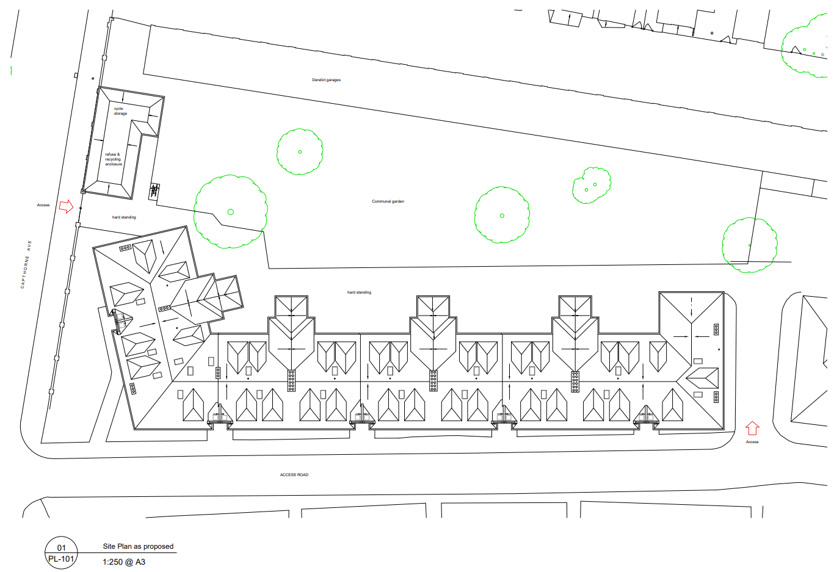
Substitute the Proposed Ground Floor Plan drawing within Appendix 4 (Plans and Elevations) for the following drawing.

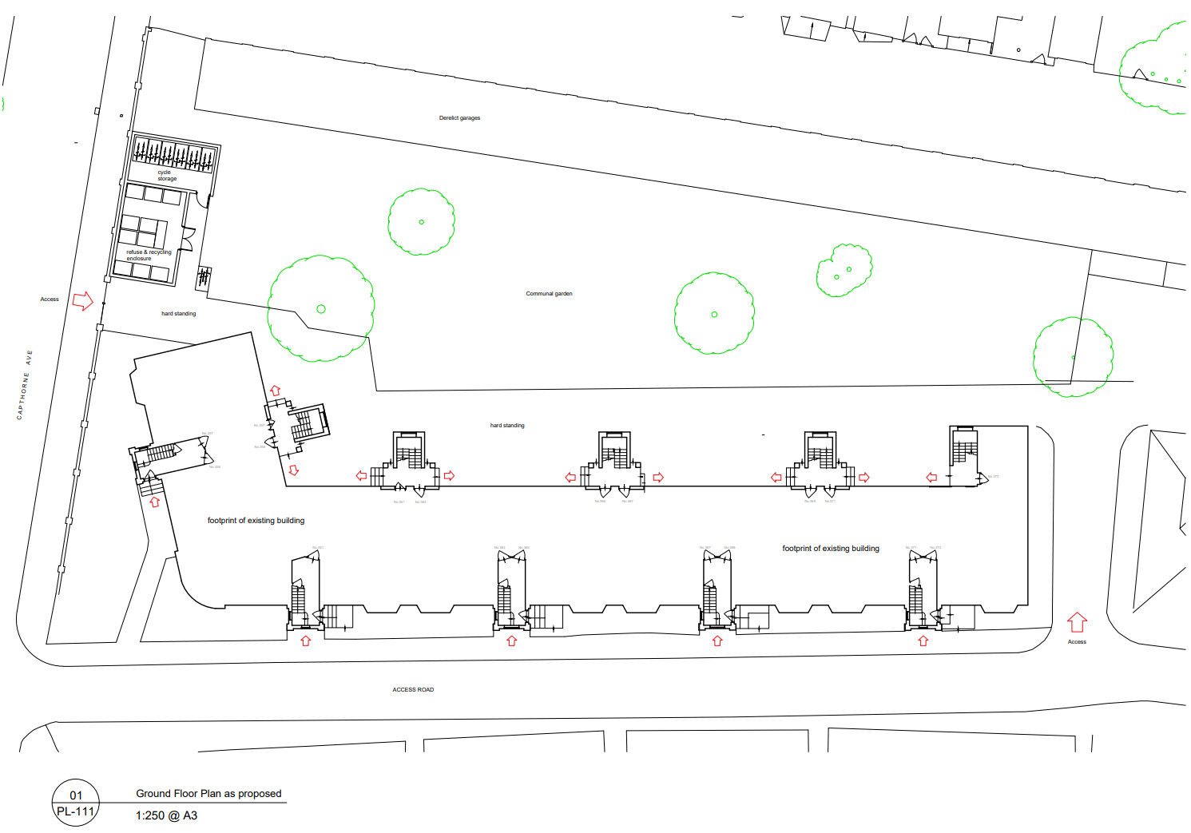

2_04 | Astley House, South Hill Avenue, Harrow, HA1 3NU
 | Astley House page 301 – Extension of time has been agreed to 30th November 2023

AGENDA ITEM 10 – REPRESENTATIONS ON PLANNING APPLICATIONS

Agenda Item | Application | Speakers
2/03 | 18 West Drive, Harrow. | Vivek sajip (Objector) will be speaking.  Amit Patel (applicant) and Dipam from TRIARCSERVICES Agent
2/04 | Astley House, South Hill Avenue, Harrow. | Mrs Sheenal Olson (Objector)  Mio Kwan (Applicant) William Lee Architect – will be speaking.

